
AMERICAN INTERNATIONAL UNIVERSITY–BANGLADESH (AIUB)
Dept. of Computer Science
Faculty of Science and Technology
CSC2210: OBJECT ORIENTED PROGRAMMING 2
Summer 2023-2024
Section: M12
Project Report On
Project Name [Online management]
Course instructor
Dr.Md.Iftekharul Mobin
Submitted By:
Name | ID
1. Navid Rahman | 24-57009-1
2. Abdullah Khan Siyam | 24-58107-1
3. Tanisha Rahman Pranty | 24-56682-1
 | Obtained Marks for CO2 and CO3 (Description given in the following page)
 | Assessment  Criteria | Not Attended/ Incorrect (0) |  |  | Inadequate  (1-2) |  |  |  | Average  (3) |  |  | Good  (4) | Excellent  (5)
 | Evaluation Criteria (CO2) |  |  | Total = |  |  |  | Evaluation Criteria (CO3) |  |  |  |  | Total =
 | Requirement fulfillment |  |  |  |  |  |  | Organization of the application
 | Validation |  |  |  |  |  |  | Representation and Integration of Database
 | Verification |  |  |  |  |  |  | Graphical User Interface
CO2: Display and verify the mean of a real-life Project using the concepts of C# Graphical User Interface based environment with database integration to depict a desktop-based application.
Assessment  Criteria |  |  | Not Attended/ Incorrect (0) |  |  | Inadequate  (1-2) |  |  |  | Average  (3) |  |  |  | Good  (4) |  | Excellent  (5)
Evaluation Criteria |  |  | Evaluation Definition
Requirement fulfillment |  |  | Fails to demonstrate any understanding of real-life scenario-based project development or functional requirement identification. There is no attempt to depict a project or identify functional requirements accurately. |  |  |  | Demonstrates limited understanding of real-life scenario-based project development and functional requirement identification. The project depicted lacks coherence or relevance to real-life scenarios, and functional requirements are inaccurately identified or insufficiently described. |  |  |  | Presents a basic depiction of a real-life scenario-based project and identifies some functional requirements. However, the project lacks depth or complexity, and some functional requirements may be vaguely defined or missing key details. |  |  |  | Effectively demonstrates a realistic scenario-based project and accurately identifies most functional requirements. The project is well-developed with appropriate complexity, and functional requirements are clearly articulated with relevant details. |  | Exhibits an exceptional understanding of real-life scenario-based project development and accurately identifies all functional requirements. The project is meticulously developed with thorough attention to detail, reflecting a comprehensive understanding of Object-Oriented Programming project development activities.
Validation |  |  | Fails to demonstrate any understanding or implementation of validation forms in their system. There is no attempt to deal with data validation, and validation requirements are completely ignored or incorrectly applied. |  |  |  | Demonstrates limited understanding of validation forms and data validation techniques. While some attempt may be made to implement validation, it is incomplete or poorly executed, leading to inadequate handling of data validation. |  |  |  | Shows a basic understanding of validation forms and data validation techniques. They attempt to implement validation, but some aspects may be missing or incorrectly implemented, resulting in partial or inconsistent handling of data validation. |  |  |  | Effectively demonstrates the use of validation forms and implements data validation techniques. Validation is mostly accurate and comprehensive, ensuring the proper handling of data input and verification in the system. |  | Exhibits an exceptional understanding and implementation of validation forms and data validation techniques. Validation is meticulously implemented with thorough attention to detail, ensuring robust data validation procedures and contributing to the overall reliability and integrity of the system.
Verification |  |  | Fails to demonstrate any attempt to verify the system data or functional requirements. There is no evidence of understanding or implementation of verification processes, and data flow is not considered. |  |  |  | Demonstrates limited understanding of verification processes and data flow in the system. Verification attempts are incomplete or inaccurate, and there is insufficient consideration given to ensuring data integrity and functionality. |  |  |  | Shows a basic understanding of verification processes and attempts to verify system data. However, verification efforts may be inconsistent or lack thoroughness, and there may be gaps in ensuring proper functional requirements and data flow. |  |  |  | Identifies and verifies system data, ensuring proper functional requirements are met. Verification efforts are mostly accurate and thorough, with attention to ensuring data integrity and appropriate data flow within the system. |  | Exhibits an exceptional understanding of verification processes and meticulously verifies system data. Verification efforts are comprehensive and precise, with a keen focus on ensuring all functional requirements are met and maintaining proper data flow throughout the system.
CO3: Prepare and Explain a real life desktop based application synthesizing several component of C# along with development tools to adhere the given requirements.
Assessment  Criteria |  |  | Not Attended/ Incorrect (0) |  |  | Inadequate  (1-2) |  |  |  | Average  (3) |  |  |  | Good  (4) |  | Excellent  (5)
Evaluation Criteria |  |  | Evaluation Definition
Organization of the application |  |  | Fails to identify any suitable real time application or requirements for project development activities related to OOP. |  |  |  | Limited understanding about the project scopes and scenarios or identification of functional requirements. |  |  |  | Lacks depth or relevance to OOP project development activities and may contain inaccuracies. Real-life scenarios are mentioned, but the discussion lacks depth or clarity. |  |  |  | Consider and integrate the idea of several core aspects of the project along with relevance to real-life scenarios. Demonstrating a solid understanding of the application presentation. |  | Generalize and exhibits an exceptional understanding of project preparation according to a to real-life scenarios. Also contains proper and insightful identification of the system which is comprehensive and precise.
Representation and Integration of Database |  |  | Fails to identify and present any understanding or implementation of database. Also failed to integrate the data with the project itself. |  |  |  | Limited understanding of the database concepts or their proper way of using in a real time project. While some attempt may be made to implement but it is incomplete or poorly executed, leading to inadequate design. |  |  |  | Lacks depth or relevance to database integration with the application. Shows a basic understanding but some aspects may be missing or incorrectly implemented, resulting in partial or inconsistency. May lack proper normalization. |  |  |  | Integrate the database with the forms properly and implements it with proper validation which is mostly accurate and comprehensive, ensuring the proper handling of data input and verification along with general normalization. |  | Exhibits an exceptional understanding and implementation of database ensuring attention to detail, and robust data manipulation procedures and contributing to the overall clarity.
Graphical User Interface |  |  | Fails to present or prepare GUI based application interfaces. There is no evidence of creating or integrating such things according to their usefulness. |  |  |  | Limited understanding of graphical user interfaces. Lack of design knowledge. Very poor attempt to make such things which are currently obsolete or can’t be identified as coherent. |  |  |  | Shows a basic understanding of creating user interfaces. Most of them are interconnected but maybe some of them lack it. However, most of it can be described as user friendly. |  |  |  | Effectively identifies and meet the consider the simplicity. Design related works are mostly accurate and taken proper attention to ensuring a user-friendly coherent system. |  | Exhibits an exceptional work design following a high standard of simple and elegant work. Several controls and mechanism has been organized in a preferred way according to the coherent usage .

Project Title: Course Management System
Introduction:
A Course Management System is a software application designed to efficiently manage student course registration, enrollment, and academic information within an educational institution. With the rapid growth of digital technology, traditional manual systems are being replaced by automated solutions that improve accuracy, reduce paperwork, and save time. This project focuses on developing a Course Management System using the .NET Framework in C#. The system provides a user-friendly interface where students can select courses, view available subjects, and manage their registration details. It also allows administrators to organize course information, monitor student enrollments, and maintain records effectively. The .NET Framework offers a powerful platform for building Windows-based applications with features such as security, scalability, and easy database integration. Using C#, the system ensures structured programming, object-oriented design, and efficient data handling. Overall, this Course Management System aims to simplify academic management processes, enhance user experience, and provide a reliable solution for handling course-related operations in a modern educational environment.
Case Study:
The Course Management System is a multiple user interaction system. In this system There are Multiple users. Each user is separated with the user types and their roles. For ex: a student can enter as a student select course according to his requirements and available courses. A teacher can take classes of the courses. Admin can see the course management views like how many students are there in each courses how the teacher is interaction with the students along with he course. The super admin has the ability to insert, delete, update, search all sorts of the users. This system shows how a vast multiple login frame is handled with the conditions of the functionalities. This is a very reliable system for the future as the educational sectors are growing.
Schema Diagram:
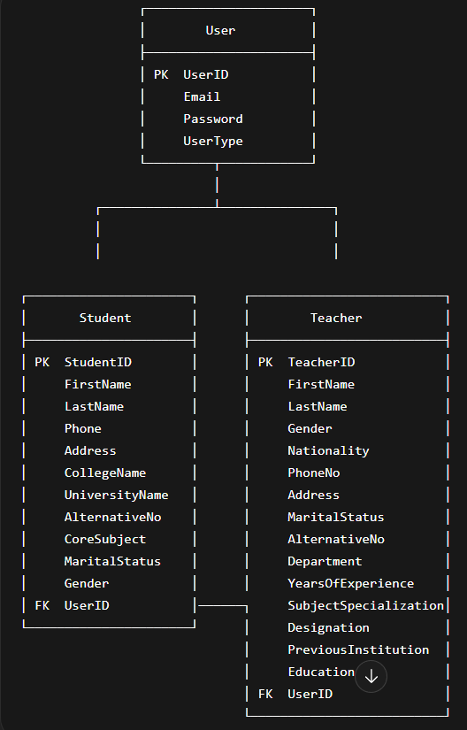
here the user login interface is create by implementing user table where the user table holds if it is a student ,teacher, admin, super admin.

DataBase Tables:
User Table:
CREATE TABLE [dbo].[User] (
[UserID] INT IDENTITY (1, 1) NOT NULL,
[Email] VARCHAR (50) NULL,
[Password] VARCHAR (50) NULL,
[UserType] VARCHAR (50) NULL,
CONSTRAINT [PK_User] PRIMARY KEY CLUSTERED ([UserID] ASC)
);
Student Table:
CREATE TABLE [dbo].[Student] (
[StudentID] INT IDENTITY (1, 1) NOT NULL,
[FirstName] VARCHAR (50) NULL,
[LastName] VARCHAR (50) NULL,
[Phone] VARCHAR (50) NULL,
[Adress] VARCHAR (50) NULL,
[CollegeName] VARCHAR (50) NULL,
[UniversityName] VARCHAR (50) NULL,
[AlternativeNo] VARCHAR (50) NULL,
[CoreSubject] VARCHAR (50) NULL,
[MaritalStatus] VARCHAR (50) NULL,
[Gender] VARCHAR (50) NULL,
[UserID] INT NULL,
CONSTRAINT [PK_Student] PRIMARY KEY CLUSTERED ([StudentID] ASC),
CONSTRAINT [FK_Student_User] FOREIGN KEY ([UserID]) REFERENCES [dbo].[User] ([UserID])
);
Teacher Table:
CREATE TABLE [dbo].[Teacher] (
[TeacherID] INT IDENTITY (1, 1) NOT NULL,
[FirstName] VARCHAR (50) NULL,
[LastName] VARCHAR (50) NULL,
[Gender] VARCHAR (50) NULL,
[Nationality] VARCHAR (50) NULL,
[PhoneNo] VARCHAR (50) NULL,
[Adress] VARCHAR (50) NULL,
[MaritalStatus] VARCHAR (50) NULL,
[AlternativeNo] VARCHAR (50) NULL,
[Department] VARCHAR (50) NULL,
[YearsOfExperience] VARCHAR (50) NULL,
[SubjectSpecialization] VARCHAR (50) NULL,
[Designation] VARCHAR (50) NULL,
[PreviuosInstitution] VARCHAR (50) NULL,
[Education] VARCHAR (50) NULL,
[UserID] INT NULL,
CONSTRAINT [PK_Teacher] PRIMARY KEY CLUSTERED ([TeacherID] ASC),
CONSTRAINT [FK_Teacher_User] FOREIGN KEY ([UserID]) REFERENCES [dbo].[User] ([UserID])
);
Normalization and Finalization:
UNF (Unnormalized Form)
UNF contains all data in a single structure with redundancy and mixed attributes.
UNF:
UserID, Email, Password, UserType,
StudentID, FirstName, LastName, Phone, Address, CollegeName, UniversityName, AlternativeNo, CoreSubject, Marital-Status, Gender,
TeacherID, FirstName, LastName, Gender, Nationality, Phone-No, Address, Marital-Status, AlternativeNo, Department, YearsOfExperience, SubjectSpecialization, Designation, PreviousInstitution, Education.
1NF (First Normal Form)
All attributes are atomic and no repeating groups exist.
1NF:
UserID, Email, Password, UserType,
StudentID, FirstName, LastName, Phone, Address, CollegeName, UniversityName, AlternativeNo, CoreSubject, MaritalStatus, Gender, UserID(FK),
TeacherID, FirstName, LastName, Gender, Nationality, PhoneNo, Address, MaritalStatus, AlternativeNo, Department, YearsOfExperience, SubjectSpecialization, Designation, PreviousInstitution, Education, UserID(FK)
2NF (Second Normal Form)
Remove partial dependency by separating common attributes into a new entity.
2NF:
1. User Table
UserID, Email, Password, UserType
2. Student Table
StudentID, FirstName, LastName, Phone, Address, CollegeName, UniversityName, AlternativeNo, CoreSubject, MaritalStatus, Gender, UserID (FK)
3. Teacher Table
TeacherID, FirstName, LastName, Gender, Nationality, PhoneNo, Address, MaritalStatus, AlternativeNo, Department, YearsOfExperience, SubjectSpecialization, Designation, PreviousInstitution, Education, UserID (FK).
3NF (Third Normal Form)
Remove transitive dependency by separating independent attributes into new tables.
3NF:
1. User :UserID, Email, Password, UserType
2. Person (Common Entity): PersonID, FirstName, LastName, Gender, Phone, AlternativeNo, Address, MaritalStatus, UserID
3. Student:StudentID, PersonID (FK), CollegeName, UniversityName, CoreSubject
4. Teacher:TeacherID, PersonID (FK), DepartmentID (FK), DesignationID (FK), YearsOfExperience, PreviousInstitution
5. Department:DepartmentID, DepartmentName
6. Designation:DesignationID, DesignationName
7. Subject:SubjectID, SubjectName
8. TeacherSubject:TeacherID (FK), SubjectID (FK)
9. Education:EducationID, PersonID (FK), Degree, Institution
Finalization
After applying normalization, the database is fully structured and optimized.
Final Database Structure:
- User(UserID, Email, Password, UserType)
- Person(PersonID, FirstName, LastName, Gender, Phone, AlternativeNo, Address, MaritalStatus, UserID)
- Student(StudentID, PersonID, CollegeName, UniversityName, CoreSubject)
- Teacher(TeacherID, PersonID, DepartmentID, DesignationID, YearsOfExperience, PreviousInstitution)
- Department(DepartmentID, DepartmentName)
- Designation(DesignationID, DesignationName)
- Subject(SubjectID, SubjectName)
- TeacherSubject(TeacherID, SubjectID)
- Education(EducationID, PersonID, Degree, Institution)
Frame Application Transition:

User Login Frame(Students,Teachers,Admin,SuperAdmin)
Student Registration Frame(the Data are stored as a student in DB after successful registration)
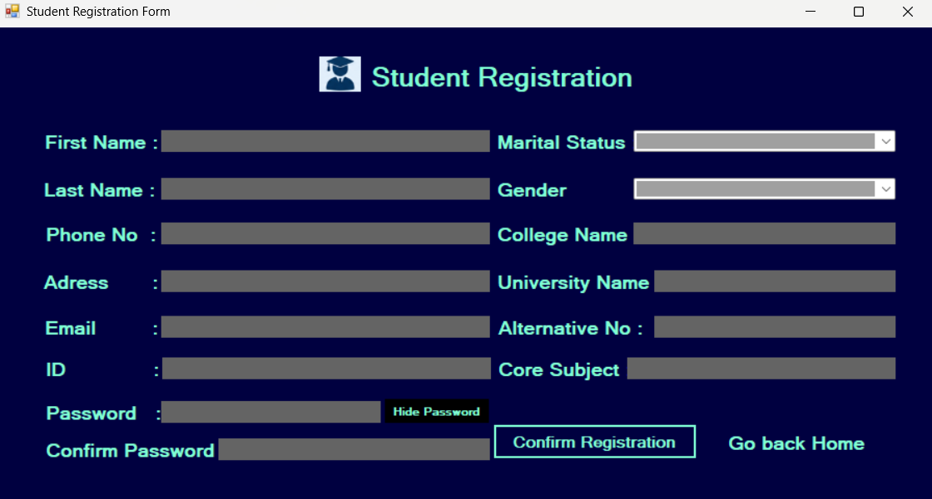
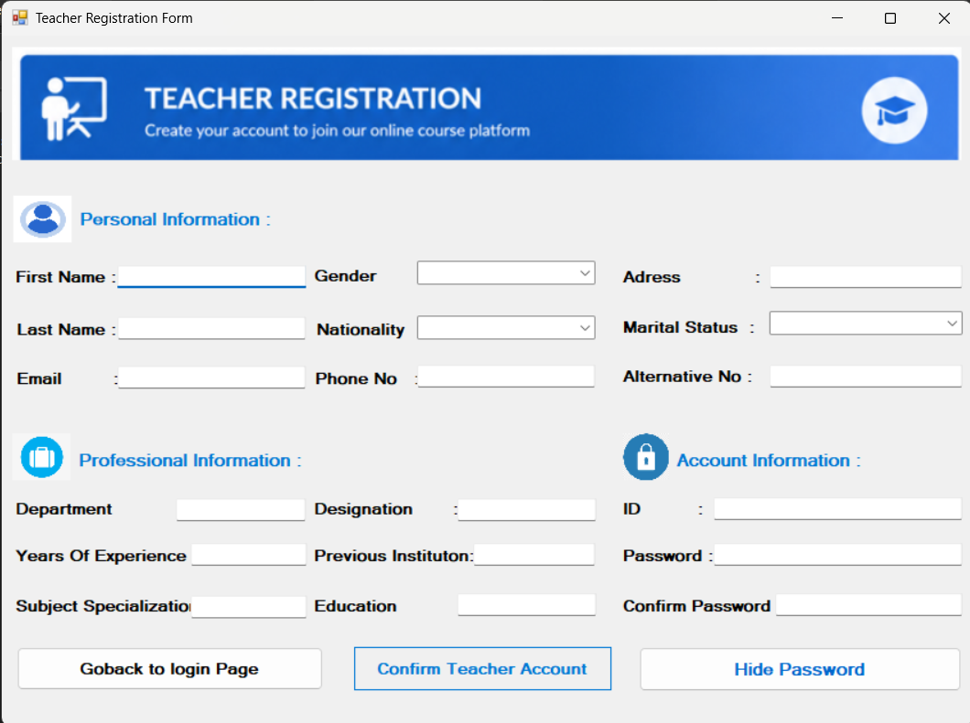
Teacher Registration Frame(the Data are stored as a teacher in DB after successful registration)

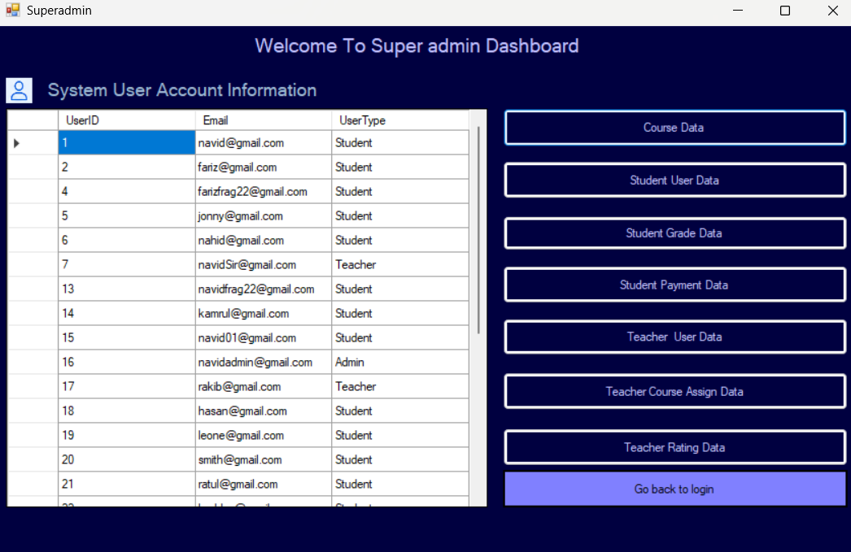
Super-admin Dashboard
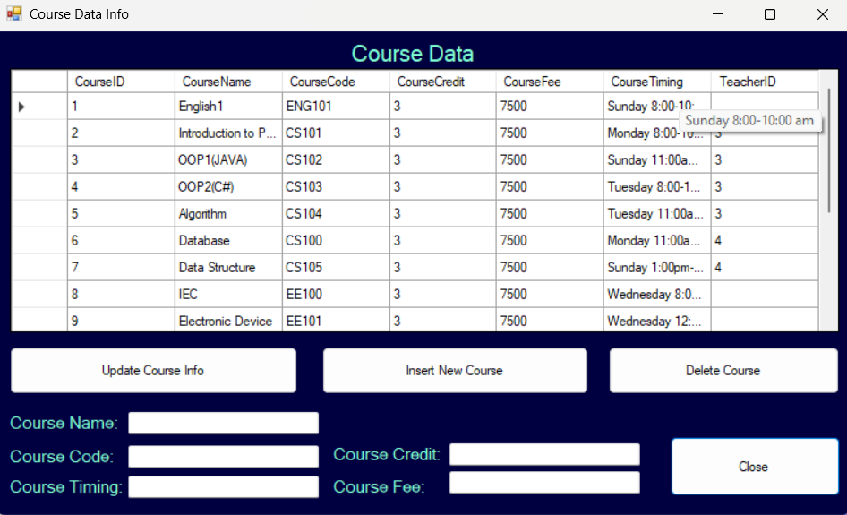
Course Insert Update Delete crud operation of the Course Table

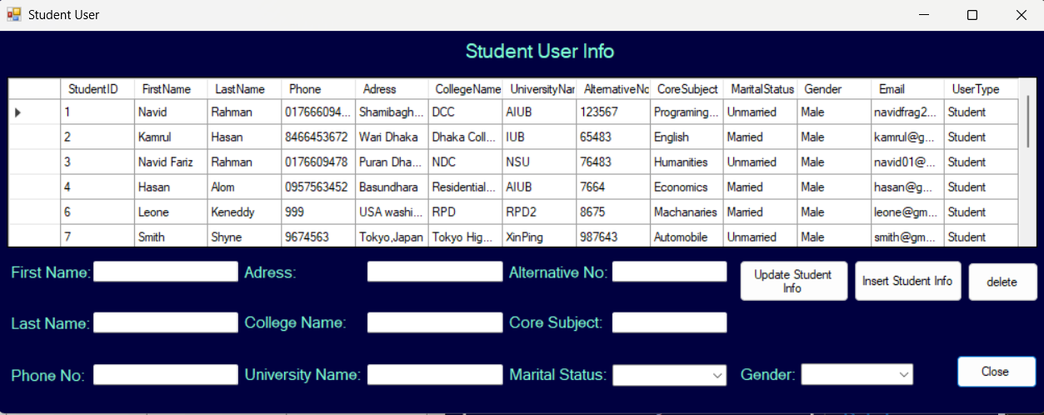
Student User Insert, Update student Info
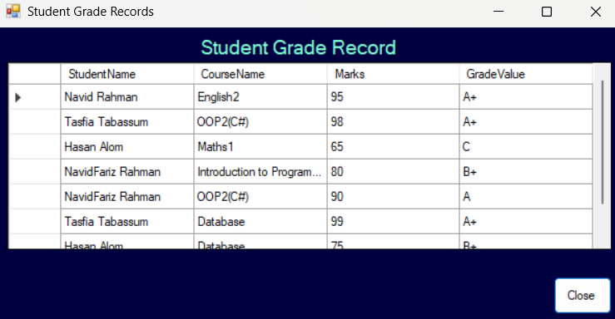
Student Grade Info
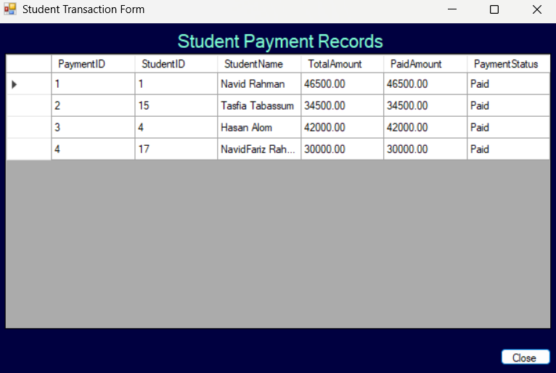

Student Payment Transaction Information
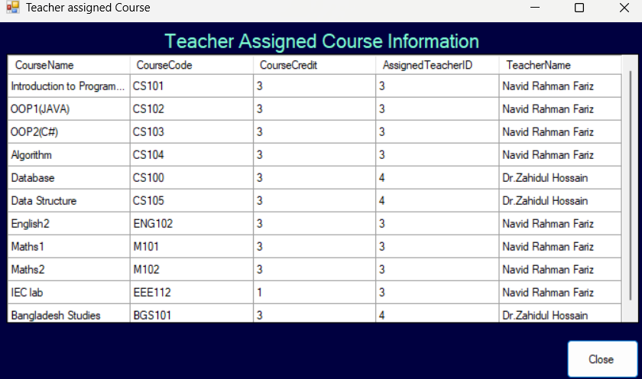
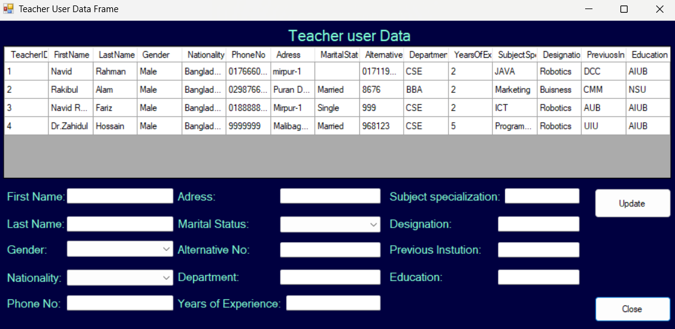
Teacher User Insert, Update, Delete Frame
Teacher assigned Course Info
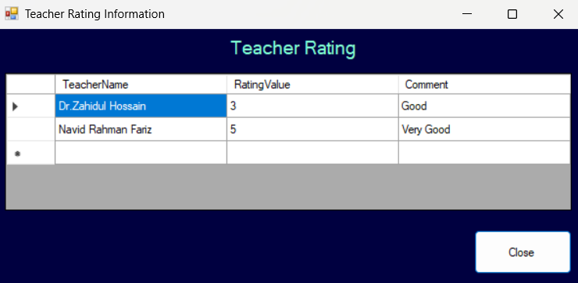
Teacher rating Info(Only the Super admin and the Student can see it)

Student Dashboard Operation Frame-work:
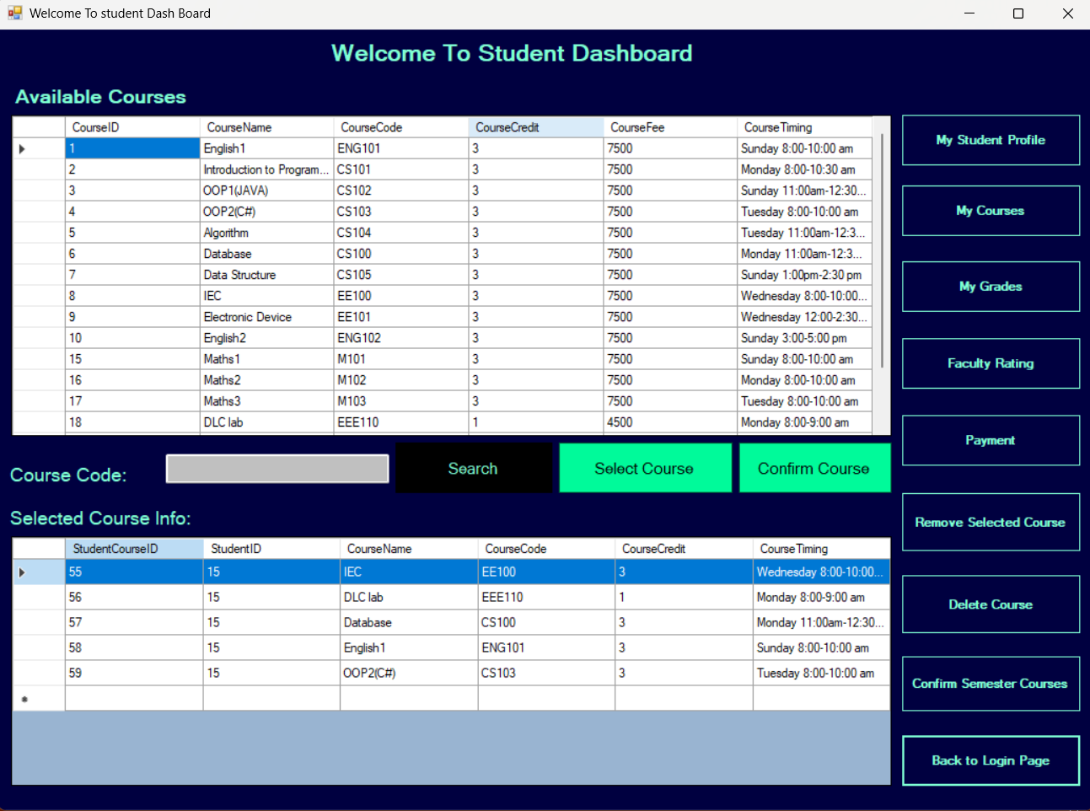
Student Dashboard for Selecting the Course
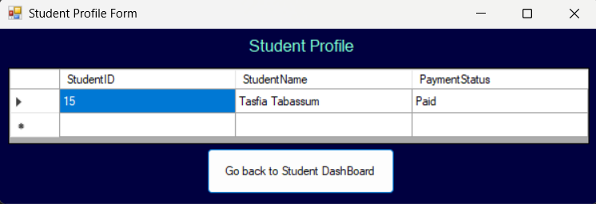
It is the student Info
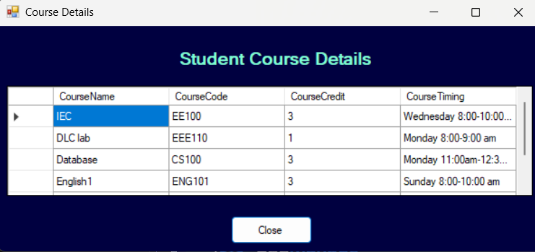
It is the student Course details Frame

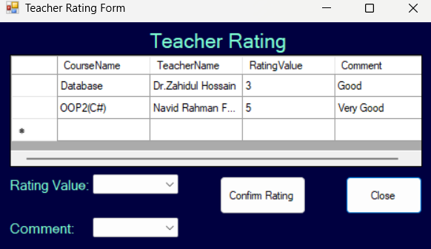


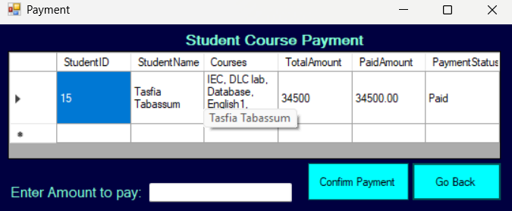

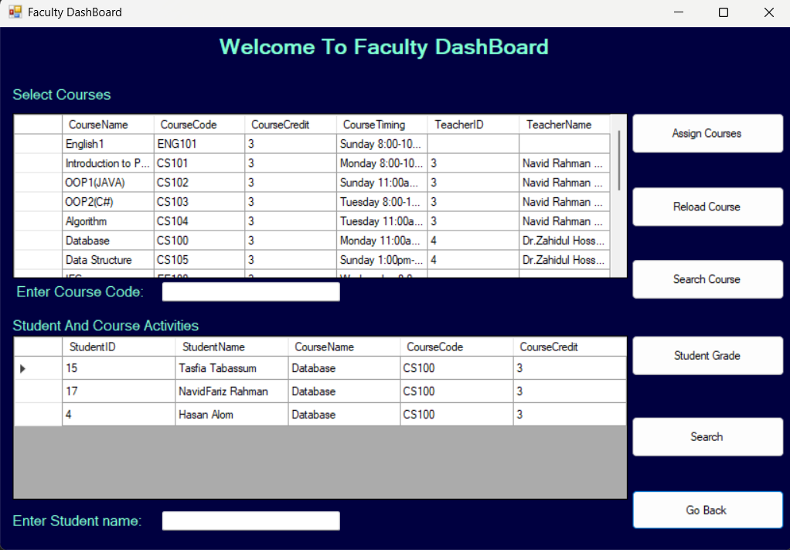

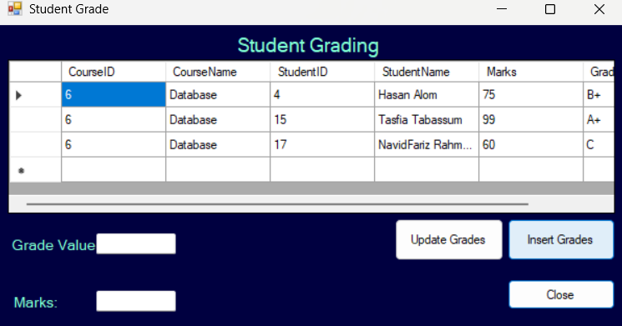

Features and Facilities:
Basic Features and Facilities
The Course Management System provides several essential features to manage students, teachers, and course-related activities efficiently. The system is designed to be user-friendly, secure, and scalable.

1. User Authentication and Authorization
- Secure login system using Email and Password
- Different user roles such as Admin, Student, and Teacher
- Access control based on user type

2. Student Management
- Add, update, delete, and view student information
- Store details like name, phone, address, college, and university
- Manage student profiles efficiently

3. Teacher Management
- Add, update, delete, and view teacher information
- Store teacher details such as department, designation, experience, and specialization
- Maintain complete teacher profiles

4. Course Management
- Create and manage courses and subjects
- Assign subjects to teachers
- Organize course-related information in a structured way

5. Enrollment System
- Students can enroll in courses
- Manage course registration records
- Track which student is enrolled in which course

6. Database Management
- Efficient storage using SQL Server
- Data normalization ensures minimal redundancy
- Fast data retrieval using queries

7. Search and Filter Functionality
- Search students or teachers by name or ID
- Filter records based on department, course, or other criteria

8. User-Friendly Interface
- Developed using Windows Forms (GUI)
- Easy navigation with buttons and forms
- Clean and organized layout

9. Data Security
- Password protection for users
- Restricted access based on roles
- Prevent unauthorized data modification

10. Record Maintenance
- Keep track of all student and teacher records
- Easy update and deletion options
- Maintain consistency in data

Facilities of the System
- Centralized system for managing academic data
- Reduces manual work and paperwork
- Improves accuracy and efficiency
- Saves time in managing records
- Easy to maintain and update
- Scalable for future enhancements
Conclusion:
The Course Management System developed using C# and the .NET Framework provides an efficient and structured solution for managing academic information related to students, teachers, and courses. The system replaces traditional manual processes with an automated approach, reducing errors, saving time, and improving overall productivity. Through proper database design and normalization up to the Third Normal Form (3NF), the system ensures data consistency, minimizes redundancy, and maintains integrity. The use of separate entities such as User, Student, Teacher, and other related tables allows for better organization and scalability of the database. The system offers essential functionalities such as user authentication, student and teacher management, course handling, and data storage, all within a user-friendly interface. It also provides flexibility for future enhancements, such as adding more modules or integrating advanced features. In conclusion, the Course Management System is a reliable and effective application that simplifies academic management tasks and demonstrates the practical implementation of object-oriented programming and database management concepts using C# and the .NET Framework.s.

